Chemistry 115 Name key
Dr. Cary Willard
Exam 1A February 22, 2010

 | Points Earned | Points Possible
Part 1  multiple choice |  | 30
Part 2  nomenclature |  | 10
Page 3 |  | 10
Page 4 |  | 20
Page 5 |  | 18
Page 6 |  | 12
Total |  | 100

Note: All work must be shown to receive credit. On calculation problems show answer with the correct number of significant figures using scientific notation if necessary.

Useful data:

$$K=℃+ 273.16$$
$$℉=\left(℃×1.8\right)+ 32$$
$$℃=\left(℉-32\right)/1.8$$

Part 1 – Multiple Choice (30 points)

- Why study chemistry?
  - To help inform us about our world
  - To be better able to make informed decisions
  - To better understand the properties of matter
  - To help us learn a technique for identifying and solving problems
  - All the above

- Which element is not reactive?
  - Hydrogen
  - Oxygen
  - Iron
  - Helium
  - Aluminum

- One meter is equal to

  - 0.001mm
  - 0.01cm
  - 100 cm
  - 100mm
  - 1000cm

- How many significant digits are in the number 540.2400?

  - 7
  - 6
  - 5
  - 4
  - Can not be determined

- A sample of an unknown substance was tested in a laboratory. The sample could not be decomposed by chemical or physical means. Based on these results the laboratory reported that the sample was most likely a(n)

  - Compound
  - Mixture
  - Atom
  - Element
  - Solution

- Which is not a physical property of water?
  - Water is colorless.
  - The freezing point of water is 0º Celsius.
  - Water reacts with sodium metal to produce sodium hydroxide and hydrogen.
  - The density of water at 4º C is 1.00g/mL.
  - Ice is not as hard as diamond.

- Which has both a definite shape and a definite volume?
  - gas
  - liquid
  - solid
  - vapor
  - plasma

- When expressed in proper scientific notation the number 0.000095532 is

  - 9.55 X 10⁵
  - 9.56 X 10⁻⁵
  - 955 X 10⁻⁷
  - 9.5532 X 10⁵
  - 9.5532 X 10^{—5}

- The elements on the periodic table are placed in order of increasing

  - Density
  - Atomic number
  - Boiling point
  - Atomic mass
  - Atomic size

- How many different elements are present in the compound NH₄NO₃?

  - 2
  - 3
  - 4
  - 5
  - 9

- Which of the following formulas contains the fewest oxygen atoms?

  - Ba(ClO₃)₂
  - K₂Cr₂O₇
  - Na₂CO₃
  - Ca(MnO₄)₂
  - Fe(NO₂)₂

- Which is a cation?

  - Cl⁻¹
  - H₂
  - Fe
  - Fe⁺²
  - Cl₂

- Which cannot be broken down chemically or physically into a simpler substance?

  - Copper
  - Sugar
  - Salt
  - Seawater
  - Lasagna

- Which of the following is a correctly written chemical symbol for an element on the periodic chart?

  - SN
  - Sn
  - ti
  - titanium
  - Fl

- 3.17g of sodium combines with chlorine to form 8.00g of sodium chloride. What is the mass of chlorine in this sample of sodium chloride?

  - 3.17g
  - 8.00g
  - 11.17g
  - 6.34g
  - 4.83g

Part 2 – Nomenclature (10 points)

Fill in the following chart with the correct name or formula for the following elements and compounds.

Compound / Element / Ion Name | Formula / Elemental / Ion Symbol
calcium | Ca
iron(III) ion | Fe⁺³
Sulfur | S
Nitride ion | N⁻³
Sodium oxide | Na₂O
Cupric iodide | CuI₂
Dibromine pentoxide | Br₂O₅
Cadmium chloride | CdCl₂
Titanium(III) oxide | Ti₂O₃
Xenon tetrafluoride | XeF₄

Part 3 – Problems and Questions (60 points)

- (6 points) Evaluate each of the following expressions. State the answer to the proper number of significant figures. (Be sure to round properly!)

  - $72.041+16.3+1901.22=\boxed{\begin{aligned} \\ 1989.6 \\ \end{aligned}}$

  - $\frac{\left(0.00966\right)(85.24)}{21.588}=\boxed{\begin{aligned} \\ 0.0381 \\ \end{aligned}}$

- (4 points) The ruler below is calibrated to measure centimeters. How long is the line in cm? 9.79 cm

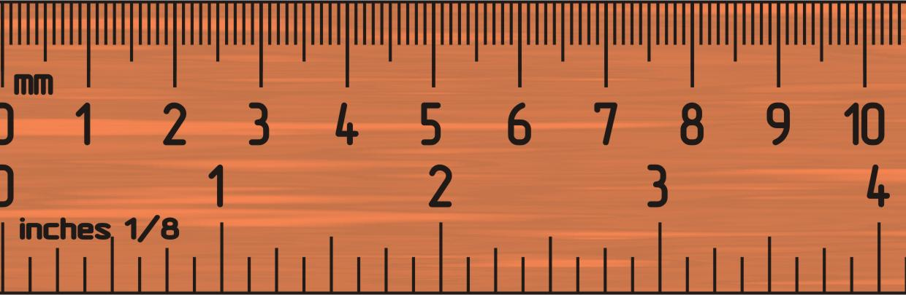
- (6 points) Round the following numbers to 3 significant figures

  - 3.54392 nm 3.54 nm

  - 57.9635 kg 58.0 kg

  - 2.1683 x 10⁻⁴ mL 2.17 x 10⁼⁴ mL

- (6 points) Complete the following metric conversions using dimensional analysis. No credit will be given without work complete with units. Give answer to the correct number of significant figures.
  - 6.34 mg to g

$$?g=6.34 mg×\frac{1 g}{1000 mg}=\boxed{9.63×{10}^{-3}g}$$

  - 72.5 cm to km

$$?km=72.5 cm×\frac{1 m}{100 cm}×\frac{1 km}{1000 m}=\boxed{7.23 ×{10}^{-4}km}$$

- (8 points) Complete the following American / metric conversions using dimensional analysis. Give answer to the correct number of significant figures (If you have forgotten a conversion factors for g to lb or cm to in, make up a number and show the correct set-up for partial credit.)

  - 3.59 kg to lb

$$?in=3.59 kg×\frac{1000 g}{1 kg}×\frac{1 lb}{454 g}= \boxed{7.91 lb}$$

  - 7.33 x 10⁻⁶ miles to nm (5280 ft = 1 mile, 1 m = 10⁹ nm)

$$?nm=7.33×{10}^{-6} mi×\frac{5280 ft}{1 mi}×\frac{12 in}{1 ft}×\frac{2.54 cm}{1 in}×\frac{1 m}{100 cm}×\frac{{10}^{9}nm}{1 m}$$
$=\boxed{1.18×{10}^{7}nm}$
- (4 points) What is the difference between a homogeneous mixture and a heterogeneous mixture?

In a homogeneous mixture all parts of the mixture are the same and have the same composition.

In a heterogeneous mixture, it is possible to see the individual components and each aliquot taken from the mixture may have a different composition

- (4 points) The mass of fuel in an airplane must be carefully accounted for before takeoff. If a 747 contains 155,000 L of fuel, what is the mass of the fuel in kilograms? The density of the fuel is 0.768 g/mL.

$$?kgfuel=155,000 L×\frac{1000 mL}{1 L}×\frac{0.768 g}{1 mL}×\frac{1 kg}{1000 g}=\boxed{119,000 kg fuel}$$

- (6 points) Iron has a density of 7.87 g/mL. If 35.8 g of iron is added to 75.0 mL of water in a graduated cylinder, to what volume reading will the water level in the cylinder rise?

$$volume in graduated cylinder=75.0 mL+4.55 mL=\boxed{79.5 mL}$$

What is the volume of the iron? (Hint: Do this part 1st)

$$?volume iron=35.8 g iron×\frac{1 mL iron}{7.87 g iron}=\boxed{4.55 mL iron}$$

- (4 points) What is the difference between a hypothesis and a theory?

A hypothesis is a tentative explanation for a process that has yet to be tested. A theory is an accepted explanation for a process which has been extensively tested and is generally accepted as being correct.
- (4 points) A solution of 18.27 g sample of sugar syrup is heated until the water has boiled off and 6.27 g of sugar remain. What percent sugar is found in the syrup?

$$?\% sugar=\left(\frac{g sugar}{g syrup}\right)×100\left(\%\right)=\left(\frac{6.27 g sugar}{18.27 g syrup}\right)×100\left(\%\right)=\boxed{34.3\% sugar}$$

- (4 points) A sample of bronze is 35.9% copper by mass. Find the mass of bronze that contains 70.0 g of copper.

$$?g bronze=70.0 g Cu×\frac{100 g bronze}{35.9 g Cu}=\boxed{195.g bronze}$$

- (4 points) The warmest temperature ever measured in the United States was 134ºF on July 10, 1913, in Death Valley, California. Convert that temperature to degrees Celsius and Kelvin.

$$℉=\left(134℃×\frac{180℉}{100℃}\right)+32℉$$
$$=241℉+32℉$$

$$=\boxed{273℉}$$

Extra credit (3 pts)
Why are coastal geographic regions normally cooler in the summer than inland geographic regions? (Be sure to use concepts of chemistry to answer this question.)
Water has a high specific heat and absorbs much of the heat in coastal regions therefore making the air cooler.

